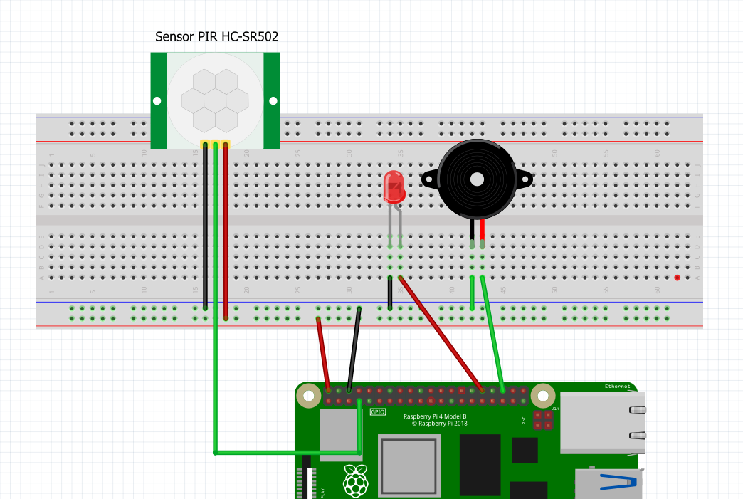

**Pin 16**

**BURGLAR ALARM WIRING USING HC-SR501 PIR SENSOR**

**HANDOUT 1**

**Pin 4**

**Pin 12**

**GND**

**5V**

**Pin 4**

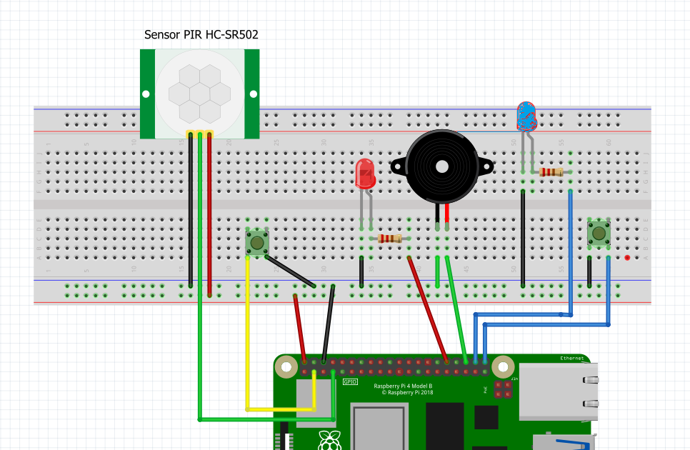

**Arming Indicator**

**Reset**

**Arming**

**Pin 16**

**Pin 21**

**Pin 20**

**Pin 2**

**Pin 12**

**Pin 4**

**HANDOUT 2**

**BURGLAR ALARM WIRING USING HC-SR501 PIR SENSOR**

**WITH ARMING AND RESET**